Publish Listing

The Publish option is used to deploy Axpert Online definition structures from the development environment to the cloud application or production environment.
The Publish Listing option is available under the Axpert Developer Studio section
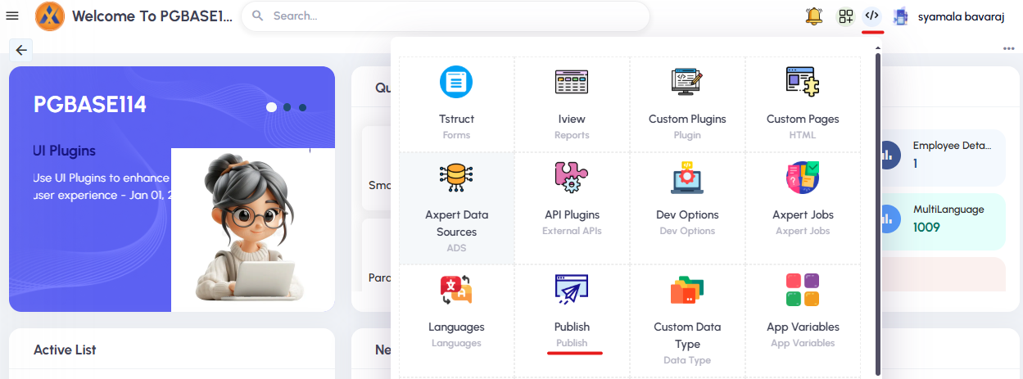
When the user clicks Publish, the Publish Listing report opens.
This report displays the publish history based on date and user.
By clicking the Details column, users can view the status of the published structures.
Within the same report, the following options are available:
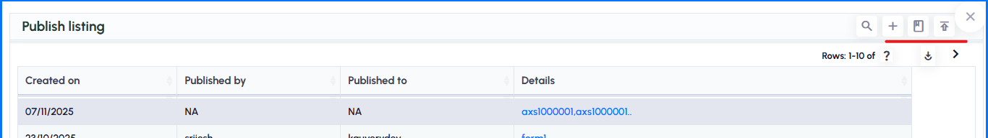
- Add server - Opens Server Details Tstruct to add new server
- List server - lists all existing server details
- Publish now - Opens Publish to Server Iview
Add Server: To create the Server Details,
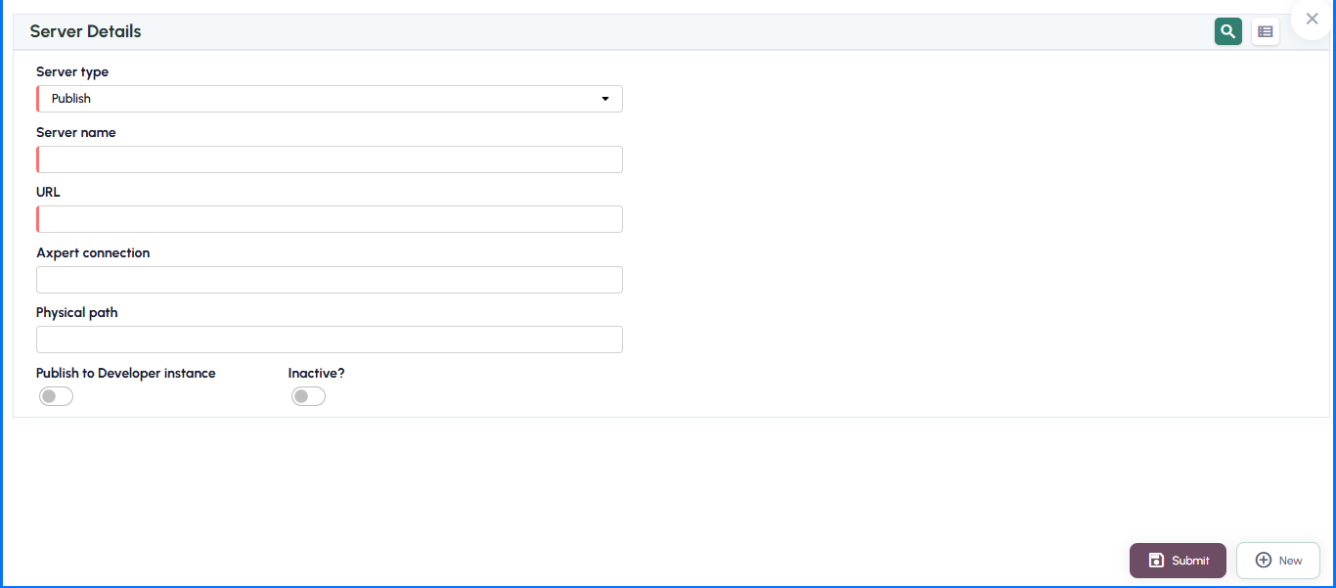
Server type - Select server type as Publish
Server name - Enter Desired Name
URL – URL should be Target Schema ARMScripts URL
EG: https://localhost/armscripts/
Axpert connection - Enter the Axpert connection name of the Target Schema.
Publish to Developer instance - If Structure needs to be published to Developer Studio, the enable the checkbox
Inactive? - User can disable the Server Details by enabling the checkbox. If it is not active the details will not list in the Server Name Params of Publish to Server Report

Publish to Server Report: This report lists Data based on the Server name and Structure Type Params values
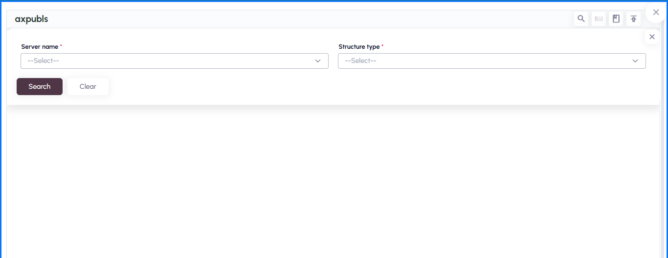
Server Name: It will list all the available configured servers.
Structure Type: Based on Structure Type, it will list the Data
- ALL - Tstruct, Iview, Responsibility, Roles, Workflow, Cards, Pages, Fast Report, Jobs, API Definition, Email Definition, Import Definition, Views, Function, Trigger, Index, Sequence.
- Axpert - Tstruct, Iview, Responsibility, Roles, Workflow, Cards, Pages, Fast Report, Jobs, API Definition, Email Definition, Import Definition.
- DB - Views, Function, Trigger, Index, Sequence.
It will have three buttons, List servers, GO and Publish Listing.
List servers – Lists the available servers.
GO – It will do publish of selected structures.
Publish Listing – It will show the History of published structures.
Publish Config Listing:
The Publish Config Listing option is available under Config Studio.
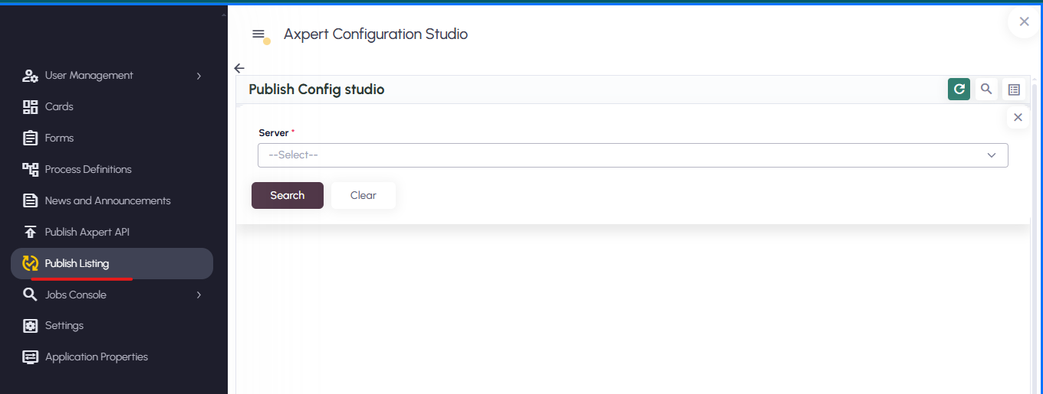
It allows users to publish various configurations to the Target Schema, such as:
- Auto Print
- Form Notification
- PEG (Process Execution Group)
- Periodic Notification
- Publish API
- Rule
Steps to Use:
- Navigate to Config Studio → Publish Config Listing.
- Select the desired Target Server from the available list.
- Click Search.
  - The system will display all the available configuration types that can be published.
- Select the required configuration type(s).
- Click Publish to deploy them to the Target Schema.

Note: While publishing from the Source to the Target, ensure that both schemas are on the same version. This prevents version mismatches and ensures a smooth publishing process

